Generic Artifact Temple
A Discussion
Collabnet, 25 Feb 2008

Table of Contents

Generic Artifact Template -Introduction 3
What is a Generic Artifact Template 3
Why A Generic Artifact Template 3
What factors to take into consideration while building a Generic Artifact 3
The format 4
<artifact> 4
<fields> 5
<Attachments> 6
A simple example of a Generic Artifact 8
Datatypes 9

Generic Artifact Template -Introduction

What is a Generic Artifact Template

The Generic Artifact Template is a set of rules according to which each system should send out its artifact data. This would enable the other components of the CCF to understand the artifact, without having to depend on the source systems formatting/native data-type handling.

Why A Generic Artifact Template

By converting any given system’s artifact in a generic artifact template, we let the other components identify the artifact’s metadata and to interpret the artifact’s data as generic data-types and data-values. These systems can then make a call on how to use this data.

We also free up the other modules from having to know about every possible artifact format in the CCF framework.

What factors to take into consideration while building a Generic Artifact

- The generic artifact should be standalone data, and during any point of time should not be dependant in anyway on the source system.
- The data types used in the generic artifact should be as per the Generic Artifact Template

Looking at the below diagram would make it clear why we need to have a Generic Artifact. The colored artifacts are all in native format. These are formats that make sense only within the respective system boundaries. However, by enforcing that each system convert their native artifact into a generic format (white artifacts), we now have artifacts that can be shipped to any system, which would also be able to read and interpret the generic format.

So, every system should have the logic to convert to and from the generic and native formats.

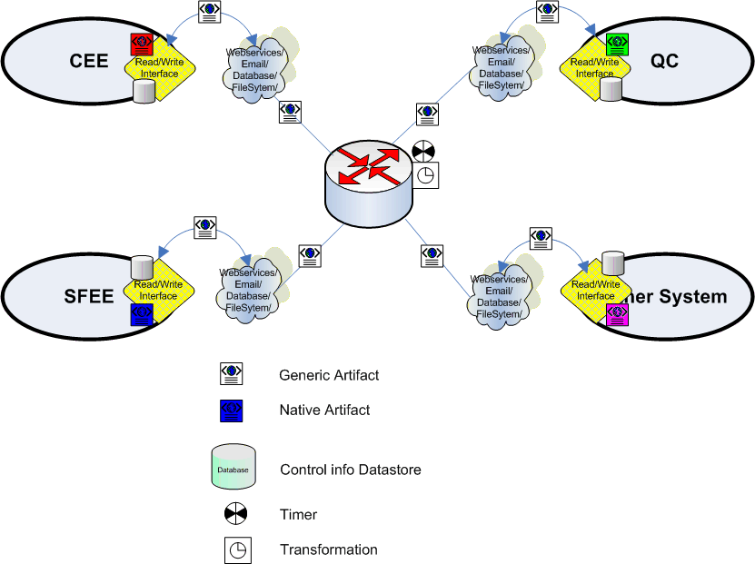

The format

<artifact>
Each artifact is represented by an ‘artifact’ tag.

<artifact type=”QCDefect” mode=”complete” action=”mod” id-field=”qc-id”>
</artifact>

The mode could be either “complete” or “changedfieldsonly” – which denote how the source system has formed this artifact. Typically, source systems are expected to provide a complete artifact (complete with all fields), but in some cases, this may not be possible, and when that happens, the source system should set this mode value to “changedfieldsonly”. Another possible use of this field in the future: This could also be used for other things like, say “dependency” to specify whether this is a dependant artifact.

The action attribute defines if this artifact has been “add”ed, “mod”ified or “del”eted. So, the three possible values of action are add, mod and del.

The id-field attribute points to a <field> tag, whose <name> sub-tag contains the same value as this id-field. That is, this provides the field, whose value should be considered as the id or primary-key for this artifact.

Each artifact is made up of one <fields> tag and one <attachments> tag.

<artifact type=”QCDefect” mode=”complete” action=”mod” id-field=”qc-id”>
<fields …>
</fields …>
<attachments …>
</attachments …>
</artifact>

<fields>
The fields tag contains zero or more <field> tags. Each <field> tag provides information about one field in the source artifact.

<field changed=”true”>
<name>priority</name>
<datatype>list</datatype>
<handle-method>replace</handle-method>
<value>P1</value>
</field>

The attribute “changed” in the field tag, specifies whether this field value was changed or not. This is needed because, the all field values of the artifact will have to be shipped, and the target system ‘may’ want to only apply the changed fields.

The <name> tag, gives the name of the field, in this case – priority.

The <datatype> tag gives the datatype of the field in the source system. In this case, it is list. However, the target system may want to treat this as a string. For a list of datatypes, please refer to the datatypes section of this document.

The <handle-method> specifies whether this data is to be appended to the existing value or replaced. The two possible values are “append” and “replace”. This is needed for fields like QC Comments, where the value has to be appended to the existing comments.

The <value> tag as implied, provides the value. If the datatype is ‘multi-select’, each list value should be provided in a separate <field> tag and <value> subtag like below:

<field changed=”true”>
<name>present-in-version</name>
<datatype>multi-select</datatype>
<handle-method>append</handle-method>
<value deleted=”false”>1.3</value>
</field>
<field changed=”true”>
<name>present-in-version</name>
<datatype>multi-select</datatype>
<handle-method>append</handle-method>
<value deleted=”false”>1.6</value>
</field>
<field changed=”true”>
<name>present-in-version</name>
<datatype>multi-select</datatype>
<handle-method>append</handle-method>
<value deleted=”false”>1.5</value>
</field>

As you can notice in the above example, the handle-method is now append, which makes sense in case of a multi-select list box. These values are to be selected in addition to whatever values already existed.

<Attachments>
The <attachments> tag may contain zero or more <attachment> tags.
<attachments>
<attachment>…</attachment>
<attachment>…</attachment>
</attachments>

Each <attachment> tag provides information about one attachment.

<attachment action=”add”>
<id>234</id>
<display-name>config-script.sh</display-name>
<src-url>http://project.pt-server.collab.net/newproj/newartifact/newattachment<src-url>
<mime-type>text/plain</mime-type>
<size>893</size>
<data>gc-link-to-stored-attachment</data>
</attachment>

The action attribute specifies what happened with this attachment for this artifact. Valid values are “add”, “mod”, “del” and “none”. The value of “none” is a possible valid value, because, there can be times when only the field values are changed, but the attachment info is sent along , due to the ‘send-the-whole-artifact’ rule. So, in these cases, where the action attribute in “none”, the <data> tag could be missing. This is necessary to avoid the huge network overhead possible with transferring files.

However, please note that all the attachment information *MUST* be provided, even when there is no change in any of the attachments. In these cases, the action should be “none” and the <data> tag could be missing – developers are recommended to make use of this to reduce network overhead, when theres no change in the attachments.

The <id> tag provides the id of the attachment.

The <display-name> could sometimes be different from the id, sometimes it is the same. In any case, these should be captured separately.

Some systems allow referring to the attachments with a unique url. The <src-url> provides such a url if available, if not available, the <src-url> tag should be present and empty.

The <mime-type> provides the mime-type of the attachment.

The <size> tag provides the size of the attachment in bytes.

The <data> tag, provides a CCF link to the data. It is the responsibility of the source reader, to contact CCF and store the attachment data into the connector core, and to embed this CCF link in the data-tag. (The specifics of this CCF store is yet to be finalized)

NOTE: <store-as>files|links</store-as> tag has deliberately been removed. This is because, this depends on the target system configuration.
As far as the source system is concerned, if its configuration prevents the attachment data from being sent because of its size, it simply does not have the <data></data> tag. In these cases the target system considers the <src-url> and tries to store the attachment as links. (It is worthwhile to note that this cue of not have a <data> tag is taken by the target system, only when the action field of the <attachment> tag is not “none”).

A simple example of a Generic Artifact
<artifact type=”QCDefect” mode=”complete” action=”mod” id-field=”qc-id”>
<fields>
<field changed=”true”>
<name>qc-id</name>
<datatype>string</datatype>
<handle-method>replace</handle-method>
<value>657</value>
</field>
<field changed=”true”>
<name>priority</name>
<datatype>list</datatype>
<handle-method>replace</handle-method>
<value deleted=”false”>P1</value>
</field>
<field changed=”true”>
<name>present-in-version</name>
<datatype>multi-select</datatype>
<handle-method>append</handle-method>
<value deleted=”false”>1.6</value>
</field>
<field changed=”true”>
<name>present-in-version</name>
<datatype>multi-select</datatype>
<handle-method>append</handle-method>
<value deleted=”false”>1.5</value>
</field>
<field changed=”true”>
<name>present-in-version</name>
<datatype>multi-select</datatype>
<handle-method>append</handle-method>
<value deleted=”false”>1.3</value>
</field>
<field changed=”true”>
<name>present-in-version</name>
<datatype>multi-select</datatype>
<handle-method>append</handle-method>
<value deleted=”true”></value>
</field>
</fields>
<attachments>
<attachment action=”add”>
<id>234</id>
<display-name>config-script.sh</display-name>
<src-url>http://project.pt-server.collab.net/newproj/newartifact/newattachment<src-url>
<mime-type>text/plain</mime-type>
<size>893</size>
<data>gc-link-to-stored-attachment</data>
</attachment>
</attachments>
</artifact>

Datatypes
The various datatypes values that are possible are:

- number
- string
- html-string (same as string, but html-escape and html-un-escape wherever necessary)
- date (date with time and time-zone)
- listbox
- multi-select (a listbox, where multiple values can be selected)
- user-combo (a special listbox, where the values are the usernames of the system)

